HORACE MANN ELEMENTARY SCHOOL
BINGHAMTON - SCHOOL

School Detail :-
This vision was developed over the course of several months by community members who engaged in a positive and productive dialogue with each other and the district about the preferred future we want for all of our studentsThis vision was developed over the course of several months by community members who engaged in a positive and productive dialogue with each other and the district about the preferred future we want for all of our studentsThis vision was developed over the course of several months by community members who engaged in a positive and productive dialogue with each other and the district about the preferred future we want for all of our studentsThis vision was developed over the course of several months by community members who engaged in a positive and productive dialogue with each other and the district about the preferred future we want for all of our students
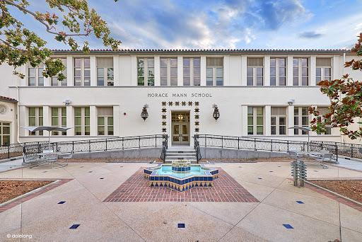

MINIMUM CAPACITY :-
The Minumum intake capacity
of students is between 280-310
children

LIBRARY :-
The Libarary is Available.

CANTEEN:-
The Canteen Facility is Available.

BOARDING :-
No availablility of boarding.

SPORTS :-
There are different categories
sports available.
Girls Volleyball
Boys Volleyball
Football

